**Application of Artificial Intelligence in Agricultural Industries - Deep Learning-Based Plant Disease Detection System**

**Introduction:**

The agriculture sector is vital to the economy, and plant diseases can cause significant losses in yield and quality. Early detection and accurate diagnosis of plant diseases are critical for effective treatment and prevention. This project aims to build an **AI-based plant disease detection system** that uses image processing and machine learning techniques to identify and classify diseases from leaf images.

**Objective:**

To develop an intelligent system that can detect and classify plant diseases from leaf images using artificial intelligence, helping farmers and agriculturists take timely and informed actions.

**Scope of the Project:**

* Detect multiple plant diseases across different crop types (e.g., tomato, potato, maize).
* Use machine learning and deep learning models for image classification.
* Provide a user-friendly interface for uploading leaf images and receiving disease predictions.
* Suggest possible treatments or preventive measures based on the diagnosed disease.

**Technologies Used:**

* **Programming Language:** Python
* **Libraries & Frameworks:** TensorFlow / Keras, OpenCV, NumPy, Matplotlib
* **Model Architecture:** Convolutional Neural Networks (CNNs)
* **Dataset:** PlantVillage dataset or a custom dataset of diseased plant leaves
* **Optional Add-ons:** Flask/Django for web interface, Mobile app for field usage

**Methodology:**

1. **Data Collection:** Gather a large dataset of plant leaf images, labeled with the disease category.
2. **Preprocessing:** Resize, normalize, and augment images for better model performance.
3. **Model Training:** Use CNNs to train the model on labeled images.
4. **Testing and Evaluation:** Evaluate model accuracy, precision, recall, and F1-score.
5. **Deployment:** Deploy the model in a web or mobile application for end-user interaction.

**Expected Outcomes:**

* High-accuracy classification of plant diseases from images.
* Reduced dependency on manual inspection.
* Time-saving and cost-effective solution for disease management.
* Potential for integration with agricultural advisory platforms

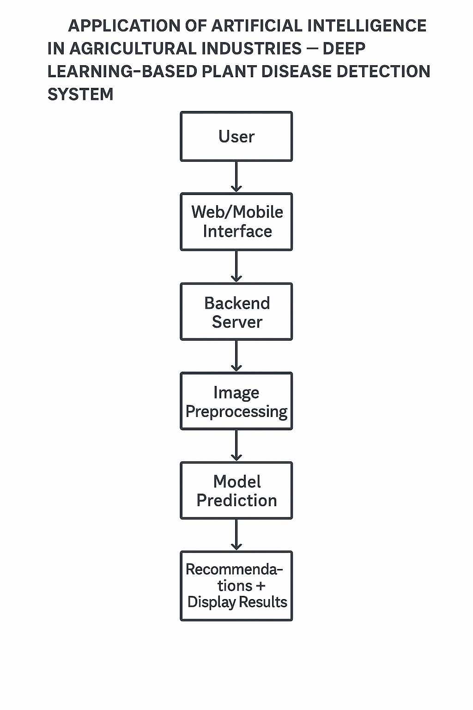

**Future Enhancements:**

* Support for real-time image capture through mobile camera.
* Integration with a recommendation engine for fertilizers and pesticides.
* Multilingual support for regional farmers.
* Weather-aware disease prediction using IoT and climate data.

**References**

1. Mohanty, S. P., Hughes, D. P., & Salathé, M. (2016). *Using Deep Learning for Image-Based Plant Disease Detection*. Frontiers in Plant Science, 7, 1419. <https://doi.org/10.3389/fpls.2016.01419>
2. Sladojevic, S., Arsenovic, M., Anderla, A., Culibrk, D., & Stefanovic, D. (2016). *Deep Neural Networks Based Recognition of Plant Diseases by Leaf Image Classification*. Computational Intelligence and Neuroscience, 2016. <https://doi.org/10.1155/2016/3289801>
3. Ferentinos, K. P. (2018). Deep learning models for plant disease detection and diagnosis. Computers and Electronics in Agriculture, 145, 311–318. https://doi.org/10.1016/j.compag.2018.01.009

Done By:

**TUMU LAKSHMAN PRASANNA KUMAR**

**2301600039**

**MCA-2(A)**

Mentor:

**Mr. J. A. Jevin**

**Assistant Professor**

Signature: